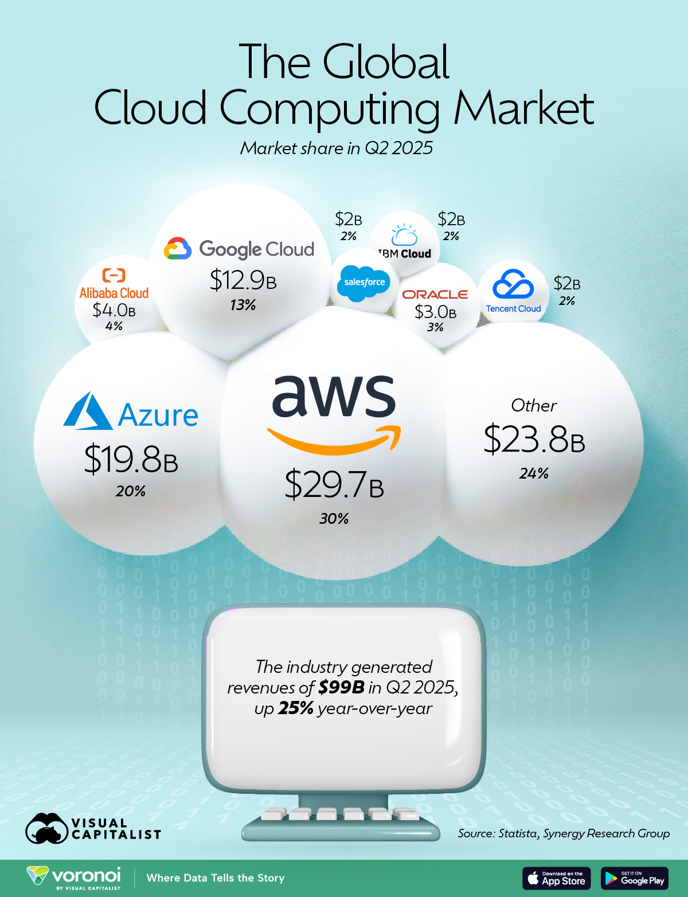

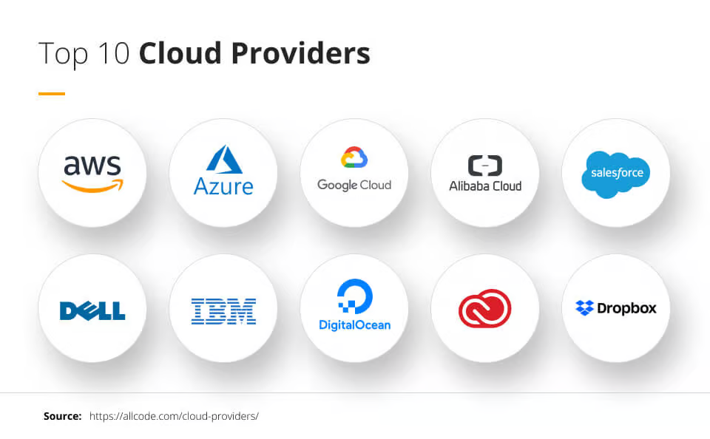

Provider | Market Share | Market Share (USD) | Country
AWS | 30% | $29.7B | 🇺🇸 US
Azure | 20% | $19.8B | 🇺🇸 US
Google Cloud | 13% | $12.9B | 🇺🇸 US
Alibaba Cloud | 4% | $4.0B | 🇨🇳 China
Oracle | 3% | $3.0B | 🇺🇸 US
Salesforce | 2% | $2.0B | 🇺🇸 US
IBM Cloud | 2% | $2.0B | 🇺🇸 US
Tencent Cloud | 2% | $2.0B | 🇨🇳 China
Other | 24% | $23.8B

https://www.geeksforgeeks.org/devops/aws-vs-google-cloud-platform-vs-azure/
https://www.datacamp.com/blog/aws-vs-azure-vs-gcp

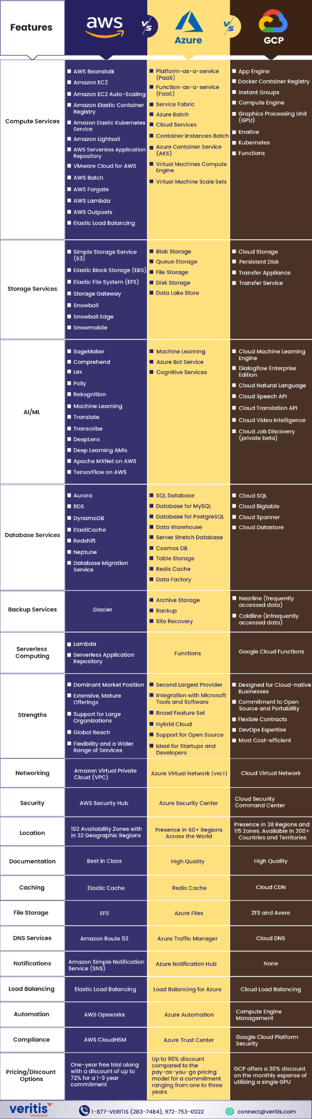

https://www.visualcapitalist.com/the-worlds-largest-cloud-providers-ranked-by-market-share/
https://techfack.com/top-10-cloud-service-providers-a-comprehensive-review/

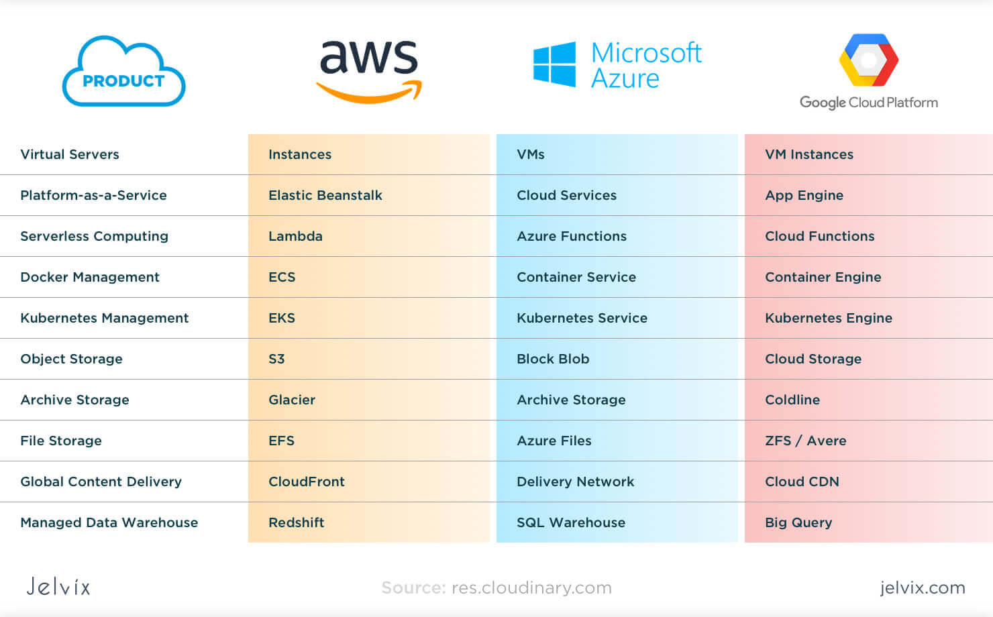

============================================================================================================================================
Here are the main cloud services commonly used across AWS, Google Cloud (GCP), and Microsoft Azure, grouped by category so you can compare them easily:

🚀 1. Compute Services
Category | AWS | GCP | Azure
Virtual Machines | EC2 | Compute Engine | Virtual Machines (VMs)
Containers | ECS, EKS | GKE (Kubernetes Engine) | AKS (Azure Kubernetes Service)
Serverless | Lambda | Cloud Functions | Azure Functions
Managed App Hosting | Elastic Beanstalk | App Engine | App Service

🗄️ 2. Storage Services
Category | AWS | GCP | Azure
Object Storage | S3 | Cloud Storage | Blob Storage
Block Storage | EBS | Persistent Disk | Managed Disks
File Storage | EFS, FSx | Filestore | File Storage
Archive Storage | Glacier | Archive Storage | Azure Archive Storage

🛢️ 3. Database Services
Category | AWS | GCP | Azure
Relational (SQL) | RDS, Aurora | Cloud SQL, Spanner | Azure SQL, Azure Database
NoSQL | DynamoDB | Firestore, Bigtable | Cosmos DB
Data Warehousing | Redshift | BigQuery | Synapse Analytics

🌐 4. Networking Services
Category | AWS | GCP | Azure
Virtual Network | VPC | VPC | Virtual Network (VNet)
Load Balancers | ELB/ALB/NLB | Cloud Load Balancing | Azure Load Balancer / App Gateway
DNS | Route 53 | Cloud DNS | Azure DNS
CDN | CloudFront | Cloud CDN | Azure CDN
VPN/Gateway | VPN Gateway | Cloud VPN | VPN Gateway

🔐 5. Security & Identity
Category | AWS | GCP | Azure
Identity | IAM | Cloud IAM | Azure AD / Entra ID
Key Management | KMS | Cloud KMS | Key Vault
Secrets | Secrets Manager | Secret Manager | Azure Key Vault (Secrets)
Security Monitoring | Security Hub, GuardDuty | Security Command Center | Defender for Cloud

📊 6. Monitoring & Management
Category | AWS | GCP | Azure
Monitoring | CloudWatch | Cloud Monitoring | Azure Monitor
Logging | CloudWatch Logs | Cloud Logging | Log Analytics
Infrastructure as Code | CloudFormation | Deployment Manager | ARM/Bicep

🤖 7. AI / ML Services
Category | AWS | GCP | Azure
ML Platform | SageMaker | Vertex AI | Azure Machine Learning
AI APIs | Rekognition, Comprehend | Vision API, NLP API | Cognitive Services

Here is a clean and clear AWS vs GCP vs Azure comparison table of the most commonly used cloud services:

🌥️ Cloud Services Comparison Table (AWS vs GCP vs Azure)
Category | AWS | GCP | Azure
Compute (VMs) | EC2 | Compute Engine | Virtual Machines
Managed Kubernetes | EKS | GKE | AKS
Container Service | ECS | Cloud Run / GKE | Azure Container Apps / ACI
Serverless | Lambda | Cloud Functions | Azure Functions
App Hosting (PaaS) | Elastic Beanstalk | App Engine | App Service
Object Storage | S3 | Cloud Storage | Blob Storage
Block Storage | EBS | Persistent Disk | Managed Disks
File Storage | EFS / FSx | Filestore | Azure Files
Archive Storage | Glacier | Archive Storage | Azure Archive Storage
SQL Databases | RDS / Aurora | Cloud SQL / Spanner | Azure SQL / Azure DB services
NoSQL Databases | DynamoDB | Firestore / Bigtable | Cosmos DB
Data Warehouse | Redshift | BigQuery | Synapse Analytics
Virtual Network | VPC | VPC | Virtual Network (VNet)
Load Balancer | ELB / ALB / NLB | Cloud Load Balancing | Azure Load Balancer / App Gateway
DNS | Route 53 | Cloud DNS | Azure DNS
CDN | CloudFront | Cloud CDN | Azure CDN
VPN Gateway | VPN Gateway | Cloud VPN | VPN Gateway
IAM (Identity) | IAM | Cloud IAM | Azure AD / Entra ID
Secrets Management | Secrets Manager | Secret Manager | Key Vault (Secrets)
Key Management | KMS | Cloud KMS | Key Vault (Keys)
Security Dashboard | Security Hub | Security Command Center | Defender for Cloud
Monitoring | CloudWatch | Cloud Monitoring | Azure Monitor
Logging | CloudWatch Logs | Cloud Logging | Log Analytics Workspace
IaC | CloudFormation | Deployment Manager | ARM / Bicep
ML Platform | SageMaker | Vertex AI | Azure Machine Learning
AI APIs | Rekognition, Comprehend | Vision API, NLP API | Cognitive Services

============================================================================================================================================

AWS Remains the Dominant Force
Amazon Web Services (AWS) maintains a strong lead, commanding 30% of the global market with nearly $30 billion in quarterly revenue.
On an annualized basis, that’s nearly $120 billion, more than the entire revenue of Nike, Disney, or Coca-Cola. AWS provides a wide range of cloud infrastructure tools, including computing, storage, databases, and developer services.

============================================================================================================================================
SERVICES USE IN AWS
STORAGE
WEB HOSTING
CONTAINER
KUBERNETICS

